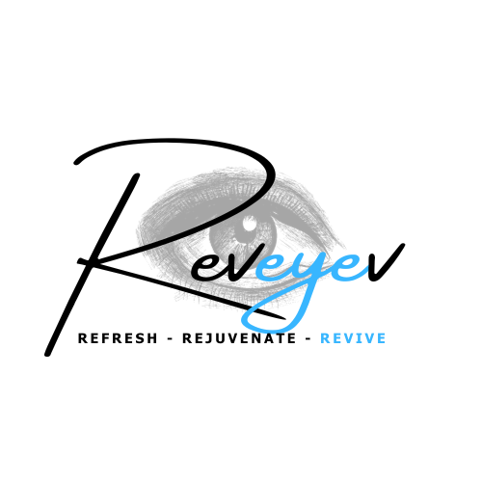  713 Washington Rd.  Pittsburgh, PA 15228  P: 412-561-1964  F: 412-561-7295  ____________________  189 East Pike Street  Canonsburg, PA 15317  P: 724-745-6258  F: 724-745-8431  Roger P. Zelt, M.D.  James B. Dickey, M.D.  Donald A Morris, D.O.  Jill K. Schuerman, O.D. | Advanced Eye Care Compassion Service  75  years  South Hills Eye Associates, Ltd.  EYE PHYSICIANS AND SURGEONS
Intense Pulsed Light (IPL/Lumecca) Pre-Post Instructions
Pre-Treatment:
- Stop Accutane at least 6 months prior to the treatment.
- Avoid sun exposure (apply sunscreen and do not tan at all – including self-tanner) for at least 2 weeks, and preferably 4 to 6 weeks before and after treatment.
- Do not use any skin irritants for a week prior to the treatment. This includes: Retinol, Benzoyl Peroxide, Isotretinoin, Glycolic/Salicylic Acids, Astringents or Vitamin C.
- Avoid taking antibiotics such as Tetracycline, Doxycycline or Minocycline for 1-2 weeks prior to IPL, as they make your skin photosensitive.
- Do not wax or use depilatory creams on the treatment area for one week prior to your treatment.
- Let your doctor know if you have a history of hyperpigmentation or have any cosmetic tattooing on or near the area to have IPL.
- Please arrive with NO makeup on eyes or face.
- Ensure no lotions or sunblock are on your face. Anything left on the skin will act as impedance to the energy and will diminish the effects.
- Do not wear jewelry to your appointment or prepare to remove it.
- Inform the doctor at least a week before treatment if you have a history of Herpetic disease (cold sores, shingles, simplex)
- Ensure you have NO open lesions or wounds or infections on the treatment area
- Do not take any painkillers, or anesthetics at least 12 hours before your treatment
Post Treatment:
- You may have a mild sunburn or burning sensation for several hours. Skin redness is normal and may last for a few days. There may be a slight amount of swelling as well. Crusting or blistering is uncommon and usually not serious.
- Use cold compresses over the treated area several times a day on the day of the IPL and for 2 days afterward.
- Your skin will be fragile for 2-3 days. Use gentle cleansers (Alumier SensiCalm is a good one). Do not rub your skin. Don’t subject the treated area to hot water during this time. Avoid skin irritants, such as any products containing Retinol, Isotretinoin, Benzoyl Peroxide, Glycolic/Salicylic Acids, Astringents, or Vitamin C for one week after treatment.
- Do not wax, scrub, exfoliate, have chemical peels, tweeze, or use depilatory creams to the treated area for a week.
- Soothing creams or moisturizers 2-3 times a day.
- Avoid the sun and use sun block (preferably SPF 30 or 40) for the first couple weeks after treatment. We like Alumier Sheer Hydration Broad Spectrum Sunscreen SPF 40.
- Sun spots and age spots often will darken with the IPL treatments before they begin to respond and resolve. This is expected and normal. Don’t scratch or pick at these spots. They usually lift and fall off without assistance.
- Please contact us as soon as possible if you experience any blistering or increased pain, you are concerned about infection, or pigment changes persist beyond 4 weeks after treatment.

I have received a copy and will follow the Pre and Post Treatment Instructions.

Patient Name: (Printed)________________________________________________________

Patient Signature: _____________________________________________________________

Date: ____________________________________
www.southhillseyeassociates.com
www.revivemedspapgh.com

