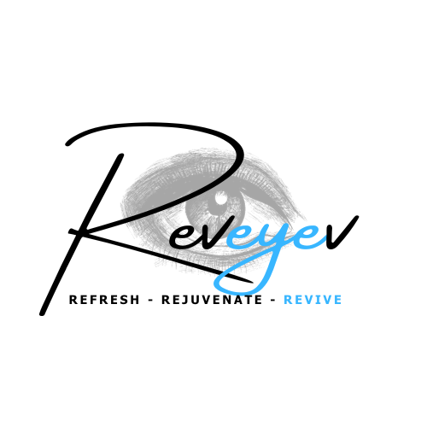  713 Washington Rd.  Pittsburgh, PA 15228  P: 412-561-1964  F: 412-561-7295  ____________________  189 East Pike Street  Canonsburg, PA 15317  P: 724-745-6258  F: 724-745-8431  Roger P. Zelt, M.D.  James B. Dickey, M.D.  Donald A Morris, D.O.  Jill K. Schuerman, O.D. | Advanced Eye Care Compassion Service  75  years  South Hills Eye Associates, Ltd.  EYE PHYSICIANS AND SURGEONS
Dry Eye (Forma-i and Lumecca-i) Pre-Post Instructions
Pre-Treatment:
- Please arrive with NO makeup on eyes or face
- Ensure no lotions or sunblock are on your face. Anything left on the skin will act as impedance to the energy and will diminish the effects
- Do not wear jewelry to your appointment or prepare to remove it
- Do not wear contact lenses to your appointment if possible (we will ask you to remove it)
- Inform the doctor at least a week before treatment if you have a history of Herpetic disease (cold sores, shingles, simplex) in the treatment area
- Neurotoxins (Botox) or fillers should be given post-treatment or a minimum of two weeks prior to any radiofrequency
- AVOID THERAPIES that can cause redness or irritation (Retina-A or products containing isotretinoin, glycolic acid or salicylic acid) for 5-7 days prior to treatment
- Ensure you have NO open lesions or wounds or infections on the treatment area
- Do not take any painkillers, or anesthetics at least 12 hours before your treatment
Post Treatment:
- You can return to normal activities after receiving the treatment
- Some swelling around the eyelids and redness in the eyes can be present 2 – 24 hours after the procedure. If the eyelid is slightly pink or red in areas following the treatment, avoid hot water when washing or showering until any erythema (redness) has subsided.
- In the process of expressing the meibomian glands, it is possible that some of the capillaries (fine blood vessels) around the eyelid can be irritated causing small petechial hemorrhages. These micro-bleeds usually resolve within 24 hours so don’t worry!
- Post treatment, the meibomian glands are expressed and some patients may feel their symptoms of dryness WORSEN for the first 24 hours. This is normal as the glands are being replenished with new healthy oils. We encourage the liberal use of artificial tears if this occurs for you.
- Do not rub your eyes post treatment for approximately 15 minutes as the mild anesthetic instilled may still be active.
- Makeup, preferably mineral-based, may be applied immediately post treatment.
- Soothing creams or moisturizers may be used.
- Use cold compresses over the eyelids for 10 minutes 3x/day on the day of the procedure and the next day.
*** CAUTION ! *** PLEASE LET US KNOW IF YOU HAVE ANY OF THE BELOW :
- Pregnant or nursing
- Poorly controlled endocrine disorders, such as diabetes, thyroid dysfunction, and hormonal virilization such as polycystic ovary syndrome
- Embedded pacemaker or ICD (implantable cardioverted defibrillator)
- Superficial implants (metal, screws, piercings)
- Ear implants
- Sensitivity to gold
- Allergic reactions to corn starch, derivatives – present in UV gel
- Been on Accutane (isotretinoin) x 6 -12 months
- Have had Botox in the last 2 weeks
- Fillers / other augmentation methods with bio material in the last 6 months
- Skin cancers or current condition of any other type of cancer or premalignant moles in the treatment area
- Severe concurrent conditions, such as cardiac disorders, sensory disturbances, uncontrolled hypertension, and liver or kidney diseases
- Diseases which may be stimulated by light at the wavelengths used, such as history of Systemic Lupus Erythematosus, Porphyria, and Epilepsy
- Impaired immune system due to immunosuppressive diseases such as AIDS and HIV or use of immunosuppressive medications
- Any surgical procedure in the treatment area within the last three months or before complete healing
- Facial laser resurfacing, facial dermabrasion, and deep chemical peeling within the last three months if face is being treated.
- Vitiligo
- Treating over tattoo or permanent makeup
- Excessively tanned skin from sun, tanning beds or tanning creams and sprays within the last two weeks

I have received a copy and will follow the Pre and Post Treatment Instructions.

Patient Name: (Printed)________________________________________________________

Patient Signature: _____________________________________________________________

Date: ____________________________________
www.southhillseyeassociates.com
www.revivemedspapgh.com

